FIGMA

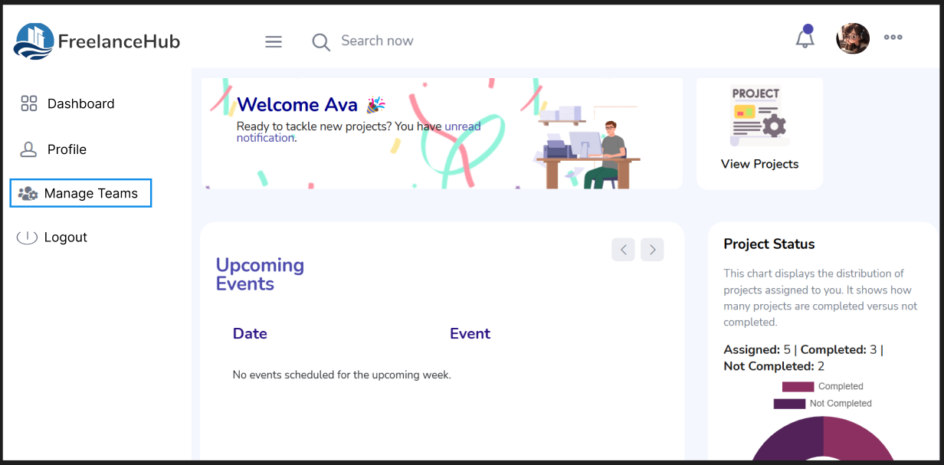

*Fig 1: Freelancer Home Page*

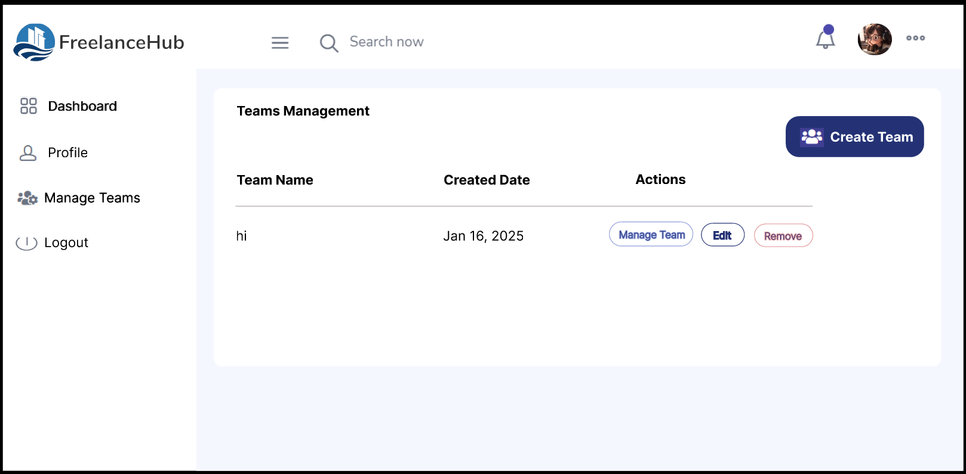

*Fig 2: Teams Management page when click*

*on manage teams from sidebar*

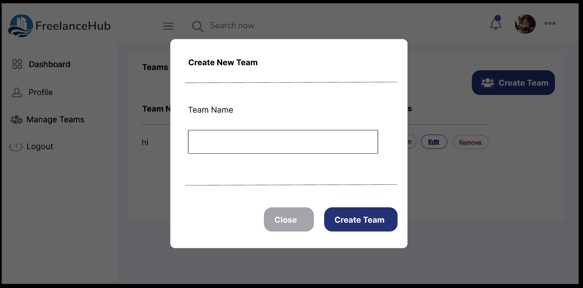

*Fig 3: Create team modal appear when*

*create team button clicked*

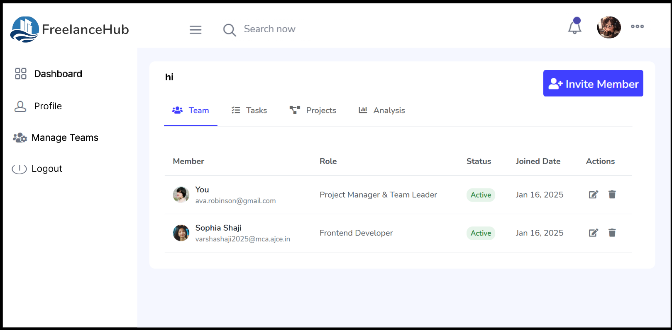

*Fig 4: Individual Team management Page*

*Appear when manage team button clicked*

*corresponds to each team name*

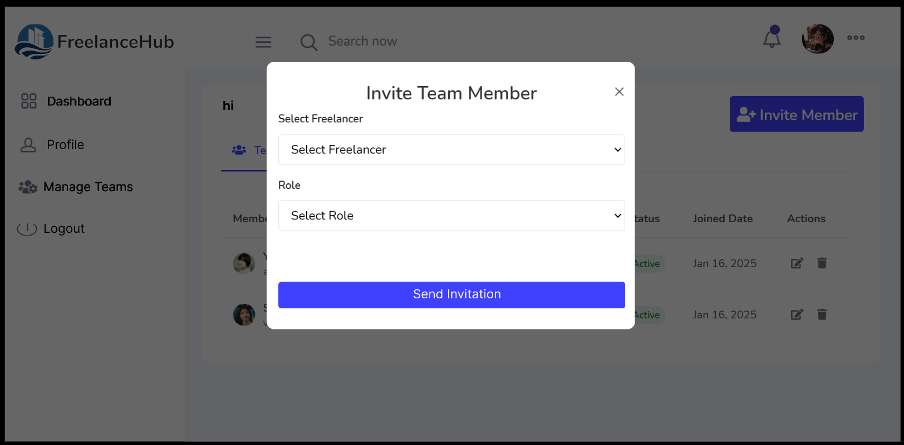

*Fig 5: Freelancer invitation modal which open*

*when invite member button clicked*

**Link :** https://www.figma.com/proto/IInJUxbkTE3o7AptdUKgfg/Untitled?node-id=1-2&t=r7AGOz6UaZvpRVNO-1&scaling=min-zoom&content-scaling=fixed&page-id=0%3A1&starting-point-node-id=1%3A2&show-proto-sidebar=1